EXPERIMENT NO. 1
AIM: To study the different types of Network cables and network topologies.
MATERIAL AND EQUIPMENT:

- Various network cables (e.g., Ethernet cables, fiber optic cables, coaxial cables)
- Networking devices (e.g., routers, switches)
- Computers or laptops
- Whiteboard and markers (for explanation)
- Access to network simulation software (optional, for visualizing topologies)

INTRODUCTION
Network cables and topologies are fundamental components of computer networks. Network administrators and IT professionals need to understand the various types of cables and topologies to design, implement, and troubleshoot network infrastructure. This practical will provide hands-on experience and knowledge about different network cables and topologies.

PROCEDURE:

Part 1: Network Cable Types
- Ethernet Cables:
An Ethernet cable or Network cable is a cord used to connect devices together on a Network to transfer broadband data. They are used for connecting a laptop or desktop PC to a router, modem, internet hub, or printer, or for connecting any other wired network-capable peripherals together.
- Fiber Optic Cables:
There are these types of cables which transport optical data signals from an attached light source to the receiving device. We are pretty much aware of what is optical fibre and its uses in a wide variety of applications.
- Coaxial Cables:
This consists of solid copper or steel conductor plated with copper which is enclosed in the metallic braid and metallic tape. This is entirely covered with an insulated protective outer jacket. These types of cables are used for computer networking and audio-video networking.
- Twisted Pair Cables:
It has two or more insulated copper wires which are twisted with each other and are colour-coded. These types of wires are usually used in telephone cables and the resistance to external interference can be measured by the number of wires.

Part 2: Network Topologies

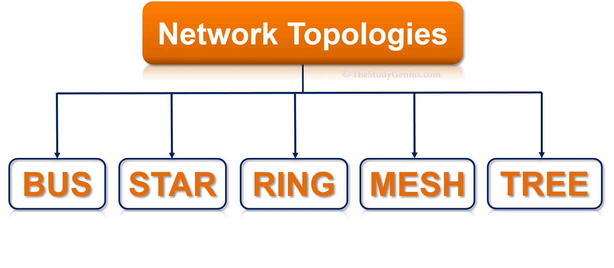

- Bus Topology:
In a bus topology, every computer is connected to a common bus. The bus is a single cable that carries data from one computer to another. If one computer wants to send data to another computer, it sends the data on the bus. All computers on the bus can see the data, but only the intended recipient will accept it..
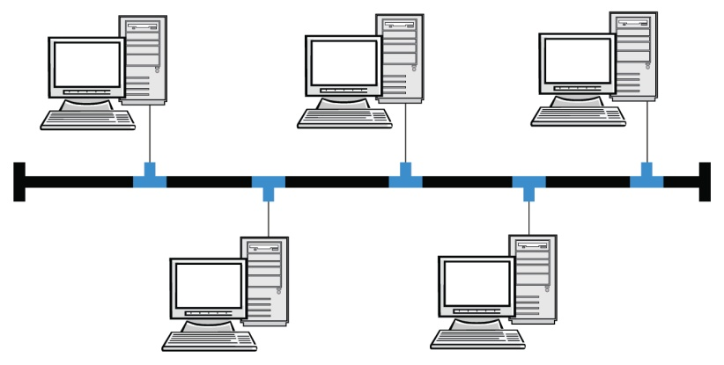

- Star Topology:
In a star topology, each device on the network is connected to a central hub. The hub acts as a gateway, providing a single point of connection for all devices on the network. Star topologies are commonly used in home and small office networks..
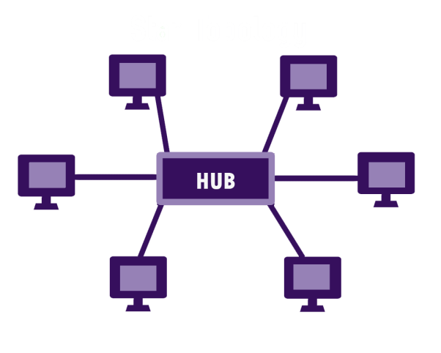
- Ring Topology:
In a ring topology, every node is connected to two other nodes, forming a loop. Data flows from one node to the next in a continuous sequence. Ring topologies are often used in fibre optic networks, where data can be transmitted at high speeds with minimal interference.
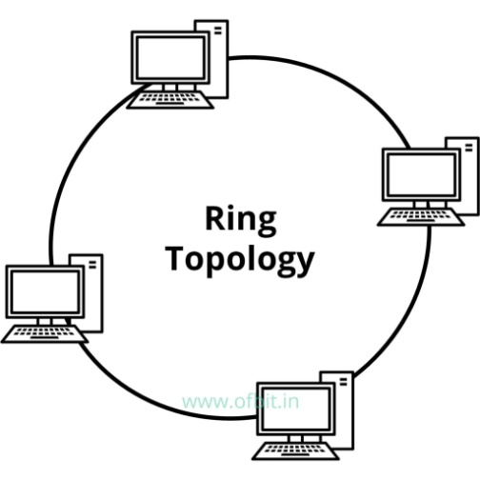
- Mesh Topology:
In computer networking, mesh topology is a type of network topology in which each node (computer or other devices) is connected to every other node in the network. A mesh topology is often used in large, complex networks because it is highly redundant and can accommodate a large number of nodes. If one node fails, the others can still communicate with each other.
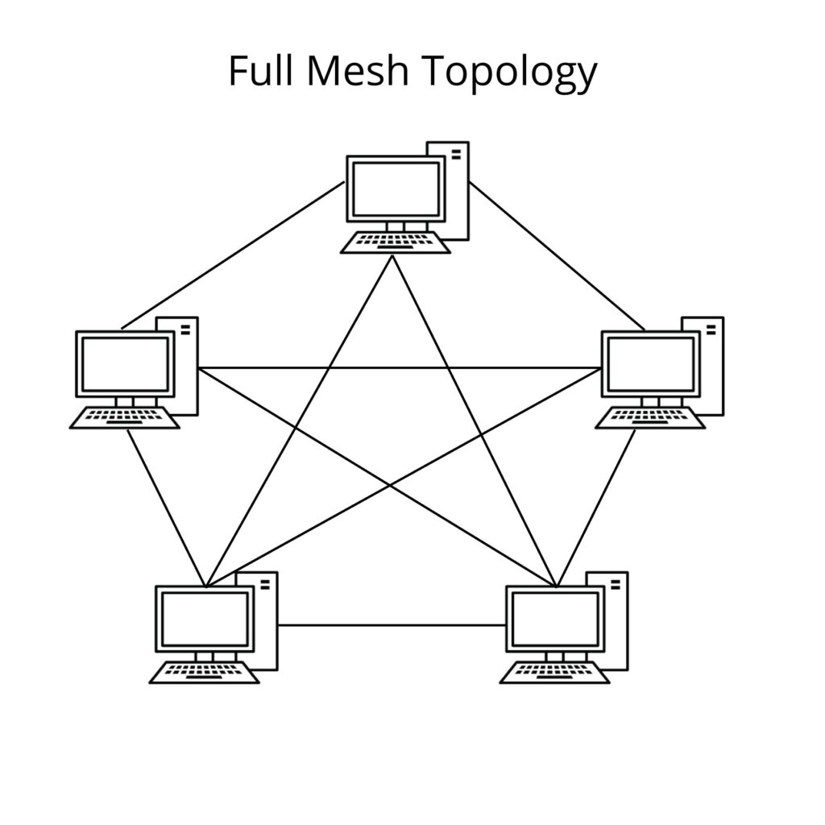
- Tree Topology:
In a tree topology, there is a central root node from which all other nodes branch out. This type of topology is often used in bus topology networks. Tree topology can be extended to an arbitrary depth, but it is usually only extended to two or three levels for the sake of simplicity.
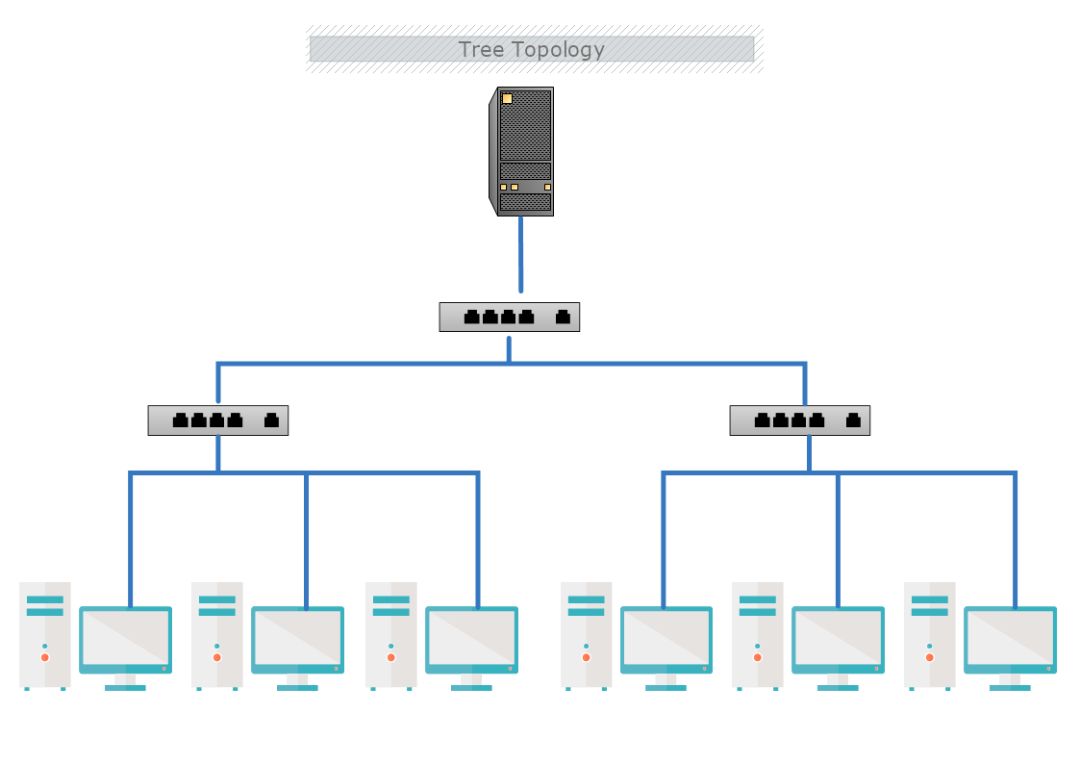

EXPERIMENT NO. 2
AIM: Practically implement and test the cross-wired cable and straight through cable using clamping tool and network lab cable tester.
MATERIAL AND REQUIREMENTS:
- Ethernet cables (bulk cable or pre-terminated cables)
- RJ-45 connectors
- Clamping tool (crimper)
- Cable tester (with two RJ-45 connectors)
- Wire stripper and cutter
- Marker and labels
- Safety goggles (for eye protection)
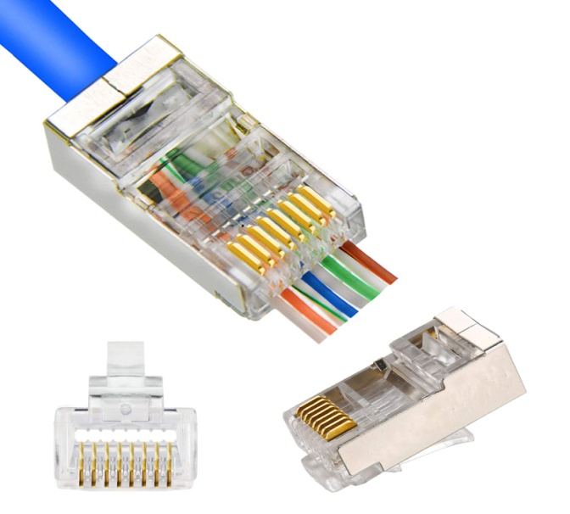
FIG: RJ-45 CONNECTOR

INTRODUCTION:
In computer networking, it's essential to understand the distinction between cross-wired (crossover) and straight-through cables. Cross-wired cables are used to connect similar devices (e.g., two computers), while straight-through cables are used to connect different devices (e.g., a computer to a switch). This practical will guide students through the process of creating and testing both cable types.
PROCEDURE:
Part 1: Cross-Wired (Crossover) Cable
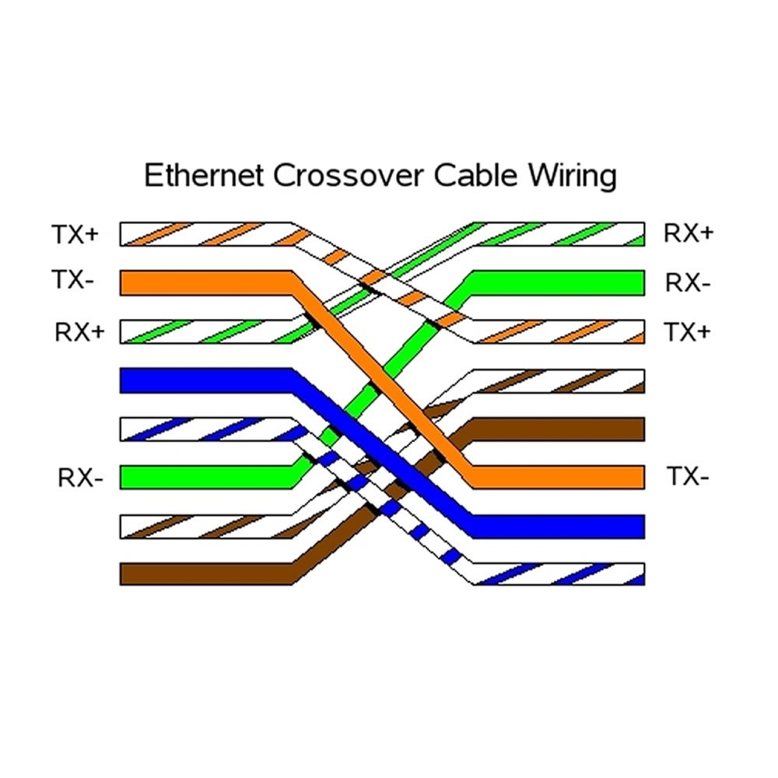
Cable Preparation:
- Start by cutting a length of Ethernet cable. Strip about 1 inch (2.5 cm) of the cable's outer insulation to expose the inner twisted pairs.
Wire Arrangement:
- Follow the T568A or T568B wiring standard for Ethernet cables.
- Cross-wire the transmit and receive wires at one end of the cable, as per the crossover cable standard (e.g., T568A at one end and T568B at the other).
Connector Termination:
- Insert the wires into an RJ-45 connector, ensuring proper alignment.
- Use a clamping tool to crimp the connector securely.
- Repeat the process for the other end, ensuring the same cross-wiring scheme.
Part 2: Straight-Through Cable
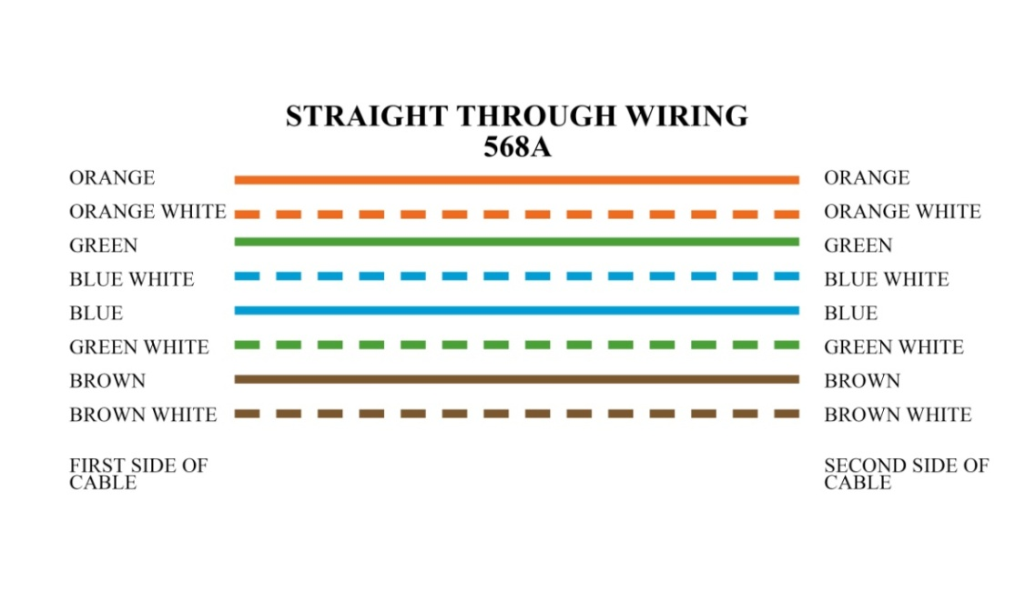
Cable Preparation:
- Cut another length of Ethernet cable. Strip about 1 inch (2.5 cm) of the cable's outer insulation to expose the inner twisted pairs.
Wire Arrangement:
- Follow either the T568A or T568B wiring standard for both ends of the cable.
Connector Termination:
- Insert the wires into an RJ-45 connector at one end, following the chosen standard.
- Use a clamping tool to crimp the connector securely.
- Repeat the process for the other end, ensuring the same wiring standard is used.

Part 3: Testing Cables
Lab Cable Tester:
- Plug one end of the created cross-wired cable into one RJ-45 connector of the lab cable tester.
- Plug the other end into the second RJ-45 connector of the tester.
- Check the tester's display for a successful connection.
- Repeat Testing for Straight-Through Cable:
- Test the straight-through cable in the same manner using the lab cable tester.
- Verify that it also shows a successful connection.

EXPERIMENT NO. 3
AIM: Study and familiarization with various network devices.
MATERIAL AND REQUIREMENTS:
- Routers
- Switches
- Hubs
- Wireless Access Points (APs)
- Firewalls
- Computers or laptops for configuration
- Network cables

INTRODUCTION:
In modern networking, various devices are crucial for establishing and maintaining network connections. Understanding these devices and their functions is fundamental to network management and troubleshooting. This practical aims to introduce students to the key network devices.

PROCEDURE:
Part 1: Introduction and Theory
Overview of Network Devices:
Begin with an explanation of the various network devices you will be covering, such as routers, switches, hubs, access points, and firewalls.
Briefly describe the primary functions and roles these devices play in computer networks.
- Repeater:
Repeaters are network devices operating at physical layer of the OSI model that amplify or regenerate an incoming signal before retransmitting it. They are incorporated in networks to expand its coverage area. They are also known as signal boosters
. 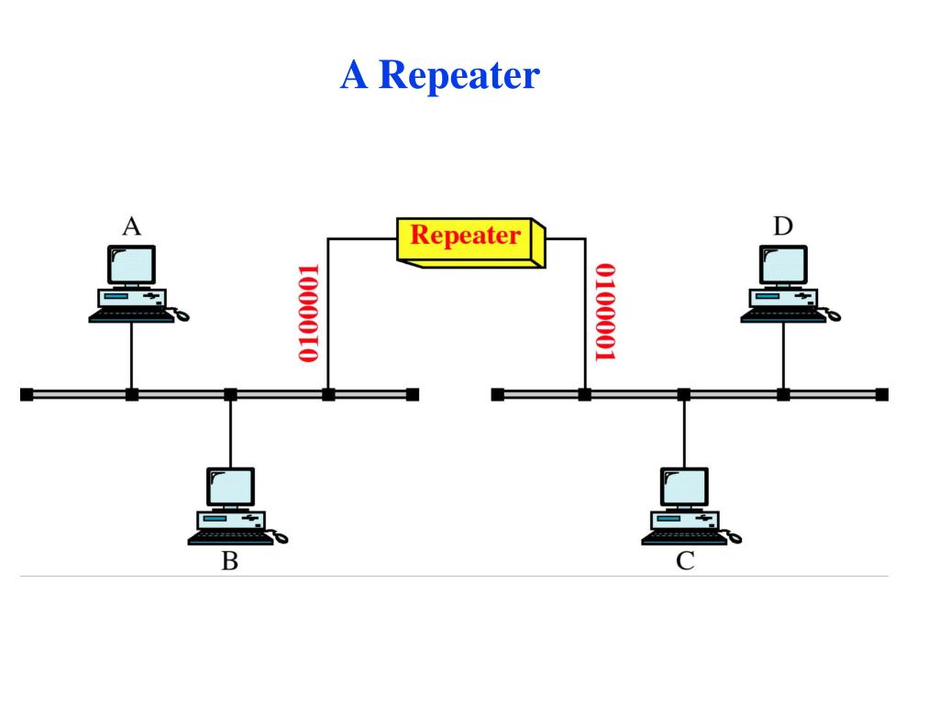

- Router:
A router is an electronic device that interconnects two or more computer networks, and selectively interchanges packets of data between them. Each data packet contains address information that router can use to determine if the source and destination are on the same network, or if the data packet must be transferred from one network to another.
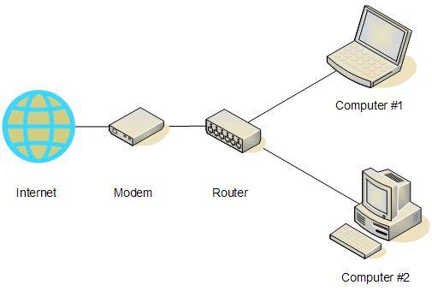

Switch:
A network switch or switching hub is a computer networking device that connects network segments. The term commonly refers to Network Bridge that processes and routes data at the data link layer (layer2) of the OSI model. Switches that additionally process data at the network layer (layer3 and above) are often referred to as Layer 3 switches or multilayer switches.
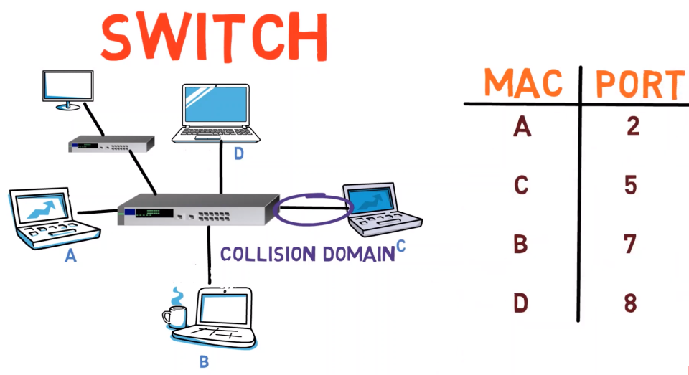
- Hub:
An Ethernet hub, active hub, network hub, repeater hub or concentrator is a device for connecting multiple twisted pair or fiber optic Ethernet devices together and making them a single network segment. Hubs work at the physical layer (layer 1) of the OSI model. The device is a form of multiport repeater.
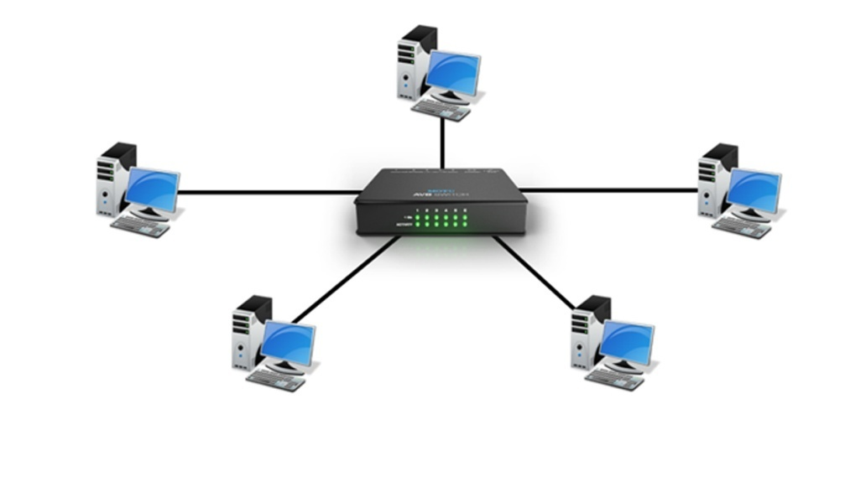
- Bridge:
A network bridge connects multiple network segments at the data link layer (Layer2) of the OSI model. In Ethernet networks, the term bridge formally means a device that behaves according to IEEE 302.1 D standards. A bridge and switch are very much alike; a switch being a bridge with numerous ports
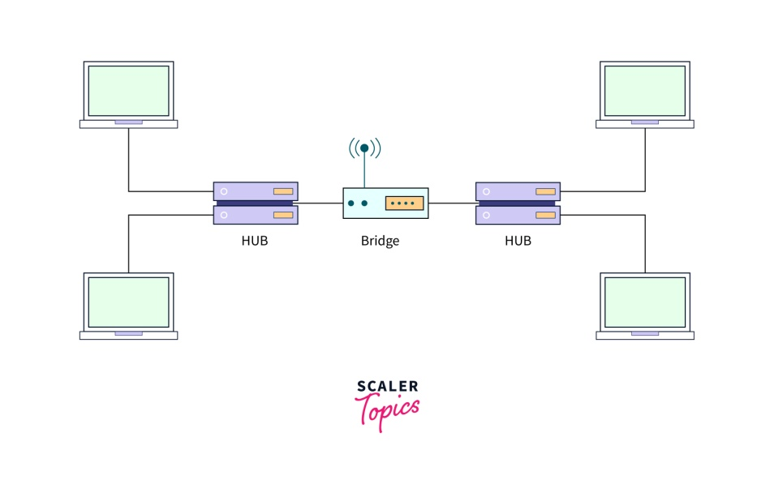
- .Firewall:
Introduce firewalls as devices designed to protect a network from unauthorized access and cyber threats.Explain their security functions, including packet filtering and stateful inspection.

Part 2: Hands-On Familiarization
Physical Examination:
- Provide physical access to the network devices.
- Encourage students to observe the device's physical characteristics, including ports, LEDs, and any labels.
Web-Based Configuration :

- If possible, access the web-based configuration interfaces of routers, switches, and wireless access points.
- Show how to log in and navigate the interface.
Port Identification:
- Identify and label the various ports on each device, including LAN, WAN, and console ports.

EXPERIMENT NO. 4
AIM: Familiarization with Packet Tracer Simulation tool/any other related tool.
MATERIAL AND REQUIREMENTS:
- Computers with Packet Tracer software installed (or access to an online version).
- Internet connectivity for downloading and installing Packet Tracer.
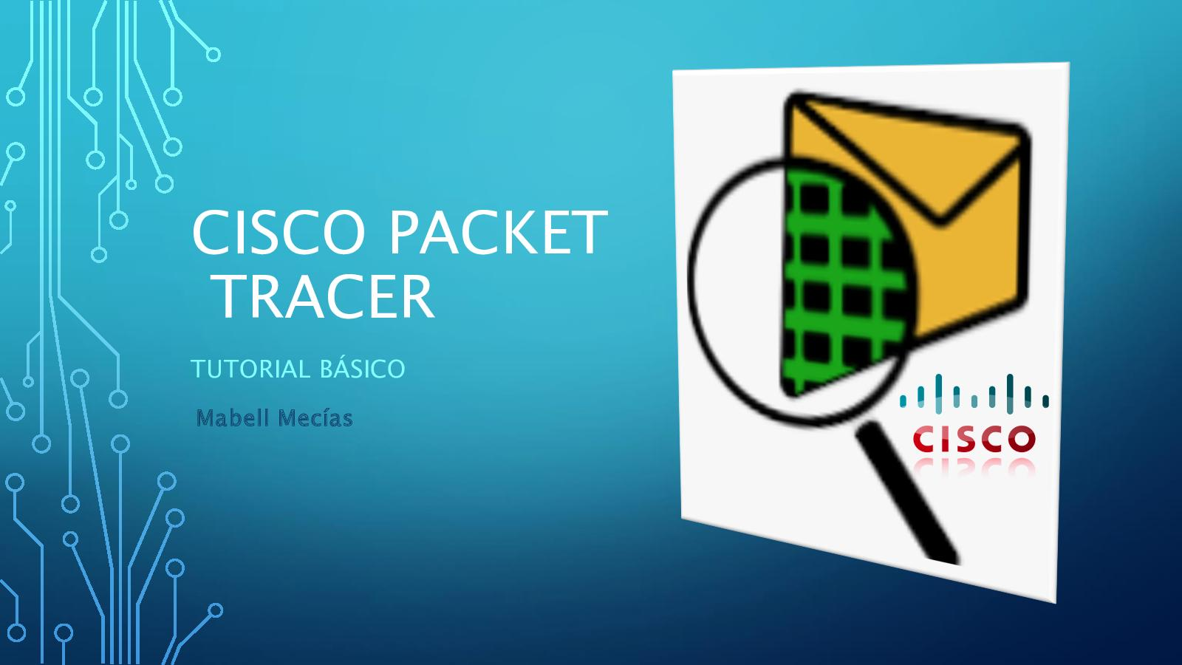
INTRODUCTION:
Packet Tracer is a valuable tool for networking students and professionals. It allows users to design, configure, and simulate network topologies without the need for physical hardware. This practical aims to familiarize students with the basics of using Packet Tracer.
PROCEDURE:
Part 1: Introduction to Packet Tracer
Overview of Packet Tracer:
- Cisco Packet Tracer is a powerful network simulation tool developed by Cisco Systems, a global leader in networking technology. It is widely used in educational settings and by networking professionals for designing, configuring, and simulating network topologies. Here is an overview of Cisco Packet Tracer:

Downloading and Installing Packet Tracer (if not already installed):
- Installation in Windows is pretty simple and straightforward; the setup comes in a single file named Packettracer_Setup6.0.1.exe. Open this file to begin the setup wizard, accept the license agreement, choose a location, and start the installation..

Launching Packet Tracer:
- Demonstrate how to launch the software and open a new project.

Part 2: Navigating Packet Tracer
User Interface:
- Present the main elements of the Packet Tracer interface, including the workspace, device palette, and toolbar.
- Explain the purpose of each section.
Creating a Simple Network:
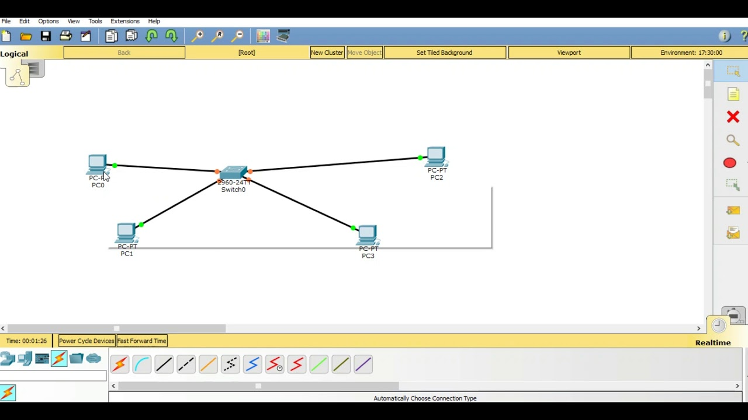

Part 3: Configuring Network Devices
Device Configuration:
- Explain how to configure network devices by double-clicking them.
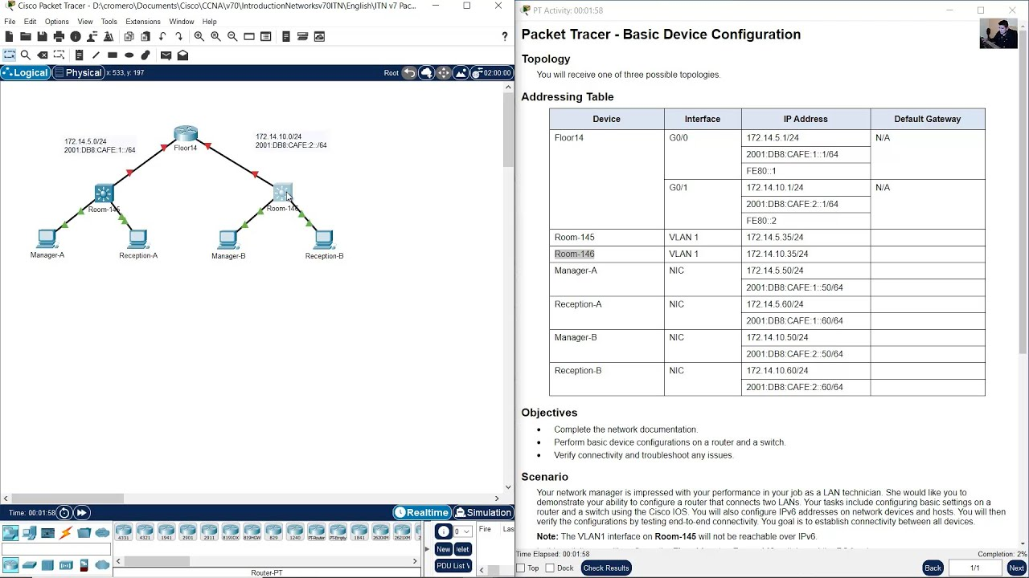

Implementing Simple Network Scenarios:
- Demonstrate how to configure a router to communicate with a switch, a PC, or another device.
- Create simple scenarios, such as setting up a local network and ensuring devices can communicate.
